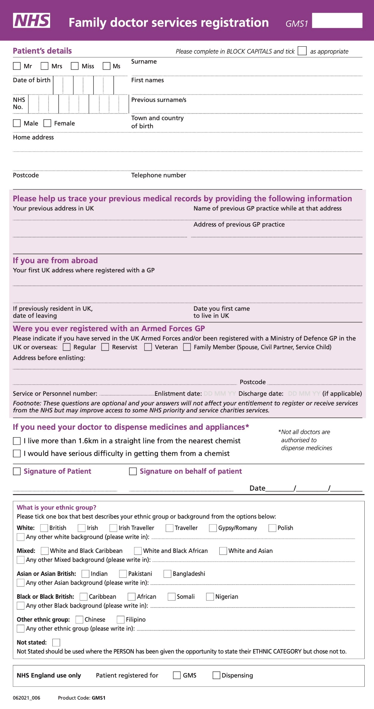

Village Surgery
The Village Surgery, Amenbury Lane, Harpenden, Hertfordshire, AL5 2BT
Phone: 01582 712021 Email:

New Patient Registration
PLEASE COMPLETE IN FULL TO AVOID ANY DELAY

About you

Surname: …………………………………… Forename(s): …….…………………………………

Date of Birth (dd/mm/yyyy): ………………. NHS number (if known): ………………………….

Gender: …………………………………… (www.nhs.uk/find-nhs-number)

Contact Information

Address:………………………………………………………………………………………………….

Telephone: ……………………………………… Mobile: ……………………………………………

Email: ………………………………………………

Please circle below your preferred choice of contact:

Text Phone Email Post

Do you live in a residential home? Yes No

Do you live in a nursing home? Yes No

What is your occupation?........................................................................................................

Residency

Previous address in the UK (if applicable):………………………………………………………….

If you are from abroad, what date did you come to UK?............................................................

Do you live in an EEA country?..................................................................................................

Service Families and Military Veterans

As a practice, we fully support the Armed Forces Covenant. We can only do this if we know our patients’ connections to the Armed Forces. Please tick the below boxes that apply to you:

I AM a Military Veteran |  | I AM currently serving in the Reserve Forces
I AM married/civil partnership to a serving member of the Regular/Reserve Armed Forces |  | I AM married/civil partnership to a Military Veteran
I AM under 18 and my parent(s) are serving member(s) of the armed forces. |  | I AM under 18 and my parent(s) are veteran(s) of the armed forces.

Ethnicity

Having information about patients’ ethnic groups would be helpful for the NHS so that it can plan and provide culturally appropriate and better services to meet patients’ needs.

If you do not wish to provide this information you do not have to do so.

Please indicate your ethnic origin by ticking the below box:

British or mixed British |  | Pakistani
Irish |  | Bangladeshi
African |  | Chinese
Caribbean |  | Other (Please state)
Indian |  | I decline to give this information

Preferred title

How would you like us to refer to you (eg Mr, Mrs, Miss, Mx)?...........................................................

Preferred title for official correspondence?...........................................................

Religious affiliation

Do you have a religious affiliation (please give details if so)?...........................................................

Country of birth

In which country were you born?...........................................................

Main language

Which is your main language?.................................................................

Do you speak English?.............................................................................

Carer status

Do you have a carer? Yes No

If Yes, please give details of their name, relationship and whether they are a patient here too………………………………………………………………………………………………………..

Are you yourself a carer? Yes No

Next of kin

Surname: …………………………………… Forename(s): …………………………………………

Gender: ……………………………………

Emergency contact Information (for next of kin)

Telephone: ……………………………………… Mobile: ……………………………………………

Contacting you

We will use your contact details to send reminders about appointments, reviews and other services which may be of benefit in your medical care

Do you consent to the Surgery sending letters to your home address? Yes No

Do you consent to the Surgery sending text messages to your mobile? Yes No

Do you consent to receiving clinical information via text to your mobile Yes No
Admin to code 2024341000006109 for consent
11934871000006104 declined consent

Do you consent to the Surgery sending messages to you by email? Yes No

Do you consent to the Surgery leaving messages on your phone? Yes No

(We will not leave detailed messages on your phone, but may ask you to contact us or leave a simple message if we do not need to speak to you).

Are you interested in joining our Patient Participation Group (PPG)? Yes No

Summary Care Record

Summary Care Record (SCR)
If you decide to have a SCR, it will contain important information about any medicines you are taking, allergies you suffer from and any bad reactions to medicines that you have had it will also include basic information about your current diagnoses. Giving healthcare staff access to this information can prevent mistakes being made when caring for you in an emergency or when your GP practice is closed. Your Summary Care Record will also include your name, address, date of birth and your unique NHS Number to help identify you correctly. If you and your GP decide to include more information it can be added, but only with your express permission.

For more information: visit https://digital.nhs.uk/services/summary-care-records-scr

I do not wish to have a Summary care Record and will decline via the link above, details on our website www.thevillagesurgeries.co.uk
(N.B. this will mean NHS Healthcare staff caring for you may
not be aware of your current medications, any allergies or
reactions to previous medication.)

Local Shared Electronic Health Record MY CARE RECORD

Local Shared Electronic Health Record
Many areas of the country have a local shared electronic health record too. Giving healthcare staff access to this information can prevent mistakes being made when caring for you in an emergency or when your GP practice is closed. Are you happy for your record to be shared across organisations caring for you? (this is accessed by relevant staff for your direct care on a need-to-know basis only)

Are you happy to be part of the local shared electronic health care record?
(if you select no, you need to be aware that NHS Healthcare staff may
not be able to see important elements of your care history)
Yes No

Electronic Prescribing Service (EPS)

The EPS allows prescribers – such as GPs and practice nurses to send prescriptions electronically to a dispenser (such as a pharmacy) of the patient’s choice. This makes the prescribing and dispensing process more efficient and convenient for patients and staff. As a practice, we would encourage all patients to opt for electronic prescribing.

I DO give consent for my prescriptions to be sent electronically to the pharmacy

I DO NOT give consent for my prescriptions to be sent electronically to the pharmacy

Nominated pharmacy……………………………………………………………………………………

Address…………………………………………………………………………………………………….

Postcode………………………………………………………………………………………………….

Donation wishes

If you live in England, Wales or Jersey, are not in a group excluded from opt out legislation and you have not registered an organ donation decision, it will be considered that you agree to be an organ donor. This is known as deemed consent.
If you do not want to donate your organs then you should register your decision to refuse to donate. Remember to speak to your family and loved ones about your decision. To opt out, visit: https://ardens.live/Organ-donation-opt-out

Do you have a donor card or are you on the organ donation register? Yes No

Have you opted out? Yes No

Do you donate blood? Yes No

Resuscitation wishes and Power of Attorney

Do you have a DNACPR (Do not attempt CPR) form in place? Yes No

Does anybody hold Lasting Power of Attorney for Health and Welfare for you?
Yes No

If YES to either of the above questions, please supply details of who holds this and where (and supply a copy for your medical notes).
Details…………………………………………………………………………………………………………………….

Smoking status

Do you smoke? Yes No

If yes, how many cigarettes do you smoke daily: ……………………………….

If no, have you smoked in the past? Yes No

Do you use electronic cigarettes/vape? Yes No

Smoking is the UK’s single greatest cause of preventable illness
Stopping smoking is not easy but it can be done, and there is now a comprehensive, NHS Smoking Cessation Service offering support and help to smokers wanting to stop, with cessation aids available on NHS prescription.

If you would like help and advice on how to give up smoking, please contact https://www.nhs.uk/live-well/quit-smoking/ or ask at reception.

Alcohol intake

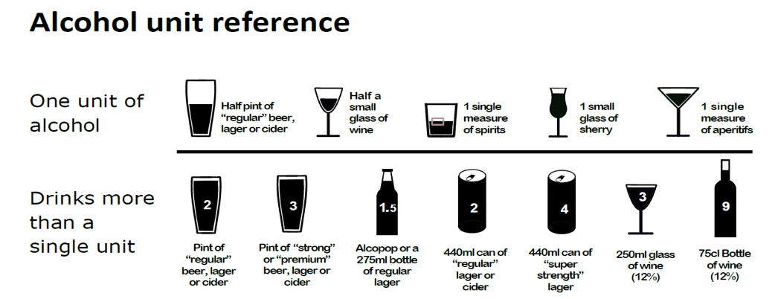
Questions | Scoring system |  |  |  |  | Your score
 | 0 | 1 | 2 | 3 | 4
How often do you have a drink that contains alcohol? | Never | Monthly or less | 2-4 times per month | 2-3 times per week | 4+ times per week
How many alcoholic drinks do you have on a typical day when you are drinking? | 1-2 | 3-4 | 5-6 | 7-9 | 10+
How often do you have 6 or more standard drinks on one occasion? | Never | Less than monthly | Monthly | Weekly | Daily or almost daily

Scoring
Score: ……………….
A total of 5+ indicates increasing or higher risk drinking. If you have a score of 5+ please complete the remaining questions below.

Questions | Scoring system |  |  |  |  | Your score
 | 0 | 1 | 2 | 3 | 4
How often during the last year have you found that you were not able to stop drinking once you had started? | Never | Less than monthly | Monthly | Weekly | Daily or almost daily
How often during the last year have you failed to do what was normally expected from you because of your drinking? | Never | Less than monthly | Monthly | Weekly | Daily or almost daily
Questions | Scoring system |  |  |  |  | Your score
 | 0 | 1 | 2 | 3 | 4
How often during the last year have you needed an alcoholic drink in the morning to get yourself going after a heavy drinking session? | Never | Less than monthly | Monthly | Weekly | Daily or almost daily
How often during the last year have you had a feeling of guilt or remorse after drinking? | Never | Less than monthly | Monthly | Weekly | Daily or almost daily
How often during the last year have you been unable to remember what happened the night before because you had been drinking? | Never | Less than monthly | Monthly | Weekly | Daily or almost daily
Have you or somebody else been injured as a result of your drinking? | No |  | Yes, but not in the last year |  | Yes, during the last year
Has a relative or friend, doctor or other health worker been concerned about your drinking or suggested that you cut down? | No |  | Yes, but not in the last year |  | Yes, during the last year

Please add up your scores from the above tables and write the total below:
Total…………………………..

If you would like help and advice on how to reduce your alcohol intake, please contact https://www.drinkaware.co.uk/ or ask at reception.

Exercise

General Practice Physical Activity Questionnaire
- Please tell us the type and amount of physical activity involved in your work.
 |  | Please mark one box only
a | I am not in employment (e.g. retired, retired for health reasons, unemployed, fulltime carer etc.)
b | I spend most of my time at work sitting (such as in an office)
c | I spend most of my time at work standing or walking. However, my work does not require much intense physical effort (e.g. shop assistant, hairdresser, security guard, childminder, etc.)
d | My work involves definite physical effort including handling of heavy objects and use of tools (e.g. plumber, electrician, carpenter, cleaner, hospital nurse, gardener, postal delivery workers etc.)
e | My work involves vigorous physical activity including handling of very heavy objects (e.g. scaffolder, construction worker, refuse collector, etc.)
- During the last week, how many hours did you spend on each of the following activities? Please answer whether you are in employment or not

Please mark one box only on each row
 |  | None | Some but less than  1 hour | 1 hour but less than  3 hours | 3 hours or more
a | Physical exercise such as swimming, jogging, aerobics, football, tennis, gym workout etc.
b | Cycling, including cycling to work and during leisure time
c | Walking, including walking to work, shopping, for pleasure etc.
d | Housework/Childcare
e | Gardening/DIY
- How would you describe your usual walking pace? Please mark one box only.
Steady average pace
Fast pace
(i.e. over 4mph)
Slow pace
(i.e. less than 3 mph)
Brisk pace

Height/Weight

What is your height: …………………………….

What is your weight:…………………………..

What is your blood pressure reading ……………………………………………
Please use the machine in the waiting room

If you would like advice on managing a healthy weight, please contact https://www.nhs.uk/live-well/ or reception who will be able to direct you to the most appropriate service.

Disabilities / Accessible Information Standards_

As a practice we want to make sure that we give you information that is clear to you. For that reason we would like to know if you have any communication needs.

Do you have any special communication needs?

Yes No

If yes, please state your needs below:

………………………………………………………………………………..

Do you have significant mobility issues? Yes No

If yes, are you housebound? Yes No
(Definition of housebound - A patient is unable to leave their home due to physical or psychological illness)

Are you blind/partially sighted? Yes No

Do you have significant problems with your hearing? Yes No

Transfusion history

Did you have a blood transfusion before 1991? Yes No

Family History and past medical history

Have any close relatives (parent, sibling or child only) ever suffered from any of the following?

Condition | Yes | No
Heart Disease (Heart attack/Angina)
Stroke
Diabetes
Asthma
Cancer

Have you yourself ever suffered from any important medical illness, operation or admission to hospital? If so please enter details below:

Condition | Year diagnosed | Ongoing?

Allergies

Please list any drug or food allergies that you have:
………………………………………………………………………………………………………………………………………………………………………………………………………………………………………………………………………………………………………………………………………………

Medications
Please provide a list of repeat medications:
………………………………………………………………………………………………………………………………………………………………………………………………………………………………………………………………………………………………………………………………………………

NHS APP

Have you signed up for the NHS app
This is where you can order repeat prescriptions, make appointments and view your medical records.

ONLINE CONSULTATIONS
For online consultations please use the link on our website www.thevillagesurgeries.co.uk

For female patients only

Are you currently pregnant? Yes No

If yes, please ensure you are under the care of a midwife. If you’re not currently under the care of a midwife please speak to reception regarding this.

Details of previous pregnancies…………………………………………………………………………….

Which method of contraception (if any) are you using at present?

……………………………………………………………………………………

Do you currently have long acting reversible contraception in place? (Implant/Coil)

Yes No

If yes, when was this fitted? (dd/mm/yy)

…………………………………
Have you had a cervical smear test? Yes No

If yes, when was this last done? (dd/mm/yy)

……………………………………

Have you had a hysterectomy? Yes No

Do you still have your ovaries? Yes No

ALL PATIENTS

If you would like a new patient consultation please book an appointment with your named GP

Please refer to our website www.thevillagesurgeries.co.uk where you will find links for online consultations, self care, making appointments, repeat prescriptions, health questionnaires, new patients.

ID SEEN PASSPORT DRIVING LICENECE OTHER……………………………

BY …………………………………………………………………………………………………………..

